Open Id connect and Oauth2.

OIDC – Open Id connect.

Oauth (open authorization) framework is a protocol is mainly used for **authorization** purpose (tells the user what to access)

Oauth generates access tokens that is used for authorization

Scopes: The permission or the authorization

Oauth2 roles have specific scopes so that the roles could access the specific set of operations

Roles of Oauth2

* Resource owner
* Resource server
* Authorization server
* Client/ Application

Resource owner: Something who owns the information

Resource server: Something who holds the information

Authorization server: Locking or giving security to the information

Client/Application: Who asks request for the authorization

Open Id connect is an extension to Oauth2 which is mainly used for the **authentication** purpose (tells only the user is valid or not)

Open Id generates id token used for authentication

Uses of OIDC

* Defines own roles and access
* Efficient to authenticate our own API’s endpoints

Tokens

* Access Token
  + Bearer token
  + JWT
  + Opaque
* Refresh Token

Access token: Used for the authorization purposes [JWT will be used]

Refresh token: Used to generate new access tokens without the reauthentication of the users

Use of Oauth2 and Open Id when combined,

* Stores user credentials
* Login security
* User registration management
* Integration of LDAP [Lightweight directory access protocol]
* Password reset process
* Two factor authentication

Cross platform authentication

User could use same login credentials to access multiple set of cross platforms applications.

Example: To host a static website in Netlify kind of page, which uses GitHub credentials to access the GitHub folders to host the website.

Grant Types

* Client credentials flow
* Authorization code flow
* Device code flow
* Refresh flow
* Password flow

Client credentials flow: Simple flow like the username/passwords flow but the client is not trusted here. Generates a secret key which gives the access keys to authorize certain operations.

Password flow: Simple flow, it has three layers user, client, server. Here client must be trusted, as client has the actual password which is insecure.

Authorization code flow: Its confidential, secure, browser based. Only the authenticated devices could access the information. User can approve the permissions to the devices for the authorization.

Flow of the application:

* The requirement mainly based on the roles specification and authorization after authentication of the roles, So this is done through a movie booking application.
* A ticket booking application have to be developed which is embedded with Oauth2 and Open Id connect.

The main roles in this application are,

* User
* Admin

The below flow explains the resources that the user can authorize,

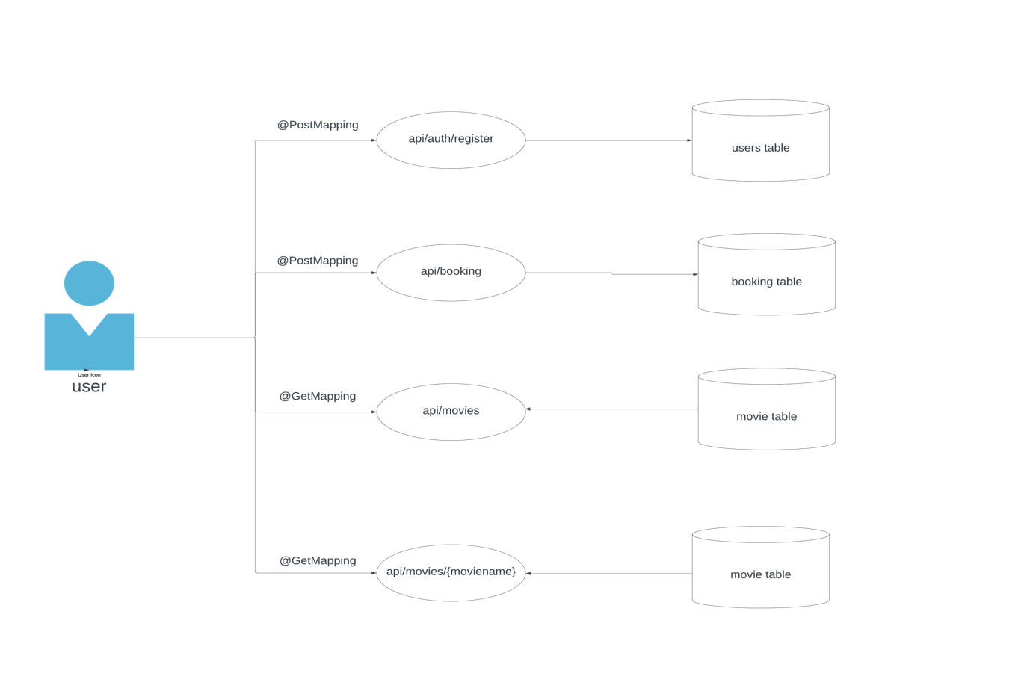

Operations of the User are,

@GetMapping

getMovies(): Can fetch all the movies from the theatre along with the details of movies, example, name, genre, showtime, director etc..,

@GetMapping

getMovie(): Can fetch only all the movie names from the theatre

@PostMapping

@addBooking(): Can able to book a ticket for a movie which needs the basic information of the user.

The below flow explains the resources that the operator can authorize,

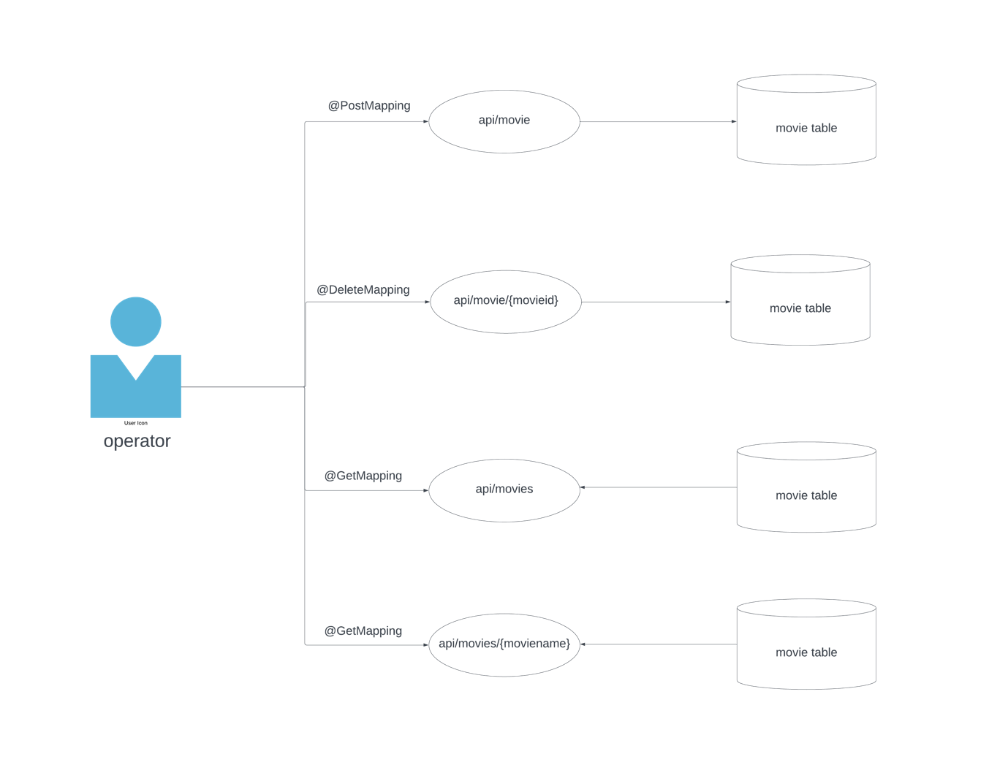

Operations of the Operator are,

@GetMapping

getMovies(): Can fetch all the movies from the theatre along with the details of movies, example, name, genre, showtime, director etc..,

@GetMapping

getMovie(): Can fetch only all the movie names from the theatre

@PostMapping

addMovie(): Can add a movie to the theatre in which the user can book tickets

@DeleteMapping

deleteMovie(): Can remove a movie from the theatre

Spring security:

* Login for authentication
* User and Operator for authorization

1. Dependencies to be added,

* Spring security

<dependency>  
 <groupId>org.springframework.boot</groupId>  
 <artifactId>spring-boot-starter-security</artifactId>  
</dependency>

* Oauth2 client

<dependency>  
 <groupId>org.springframework.boot</groupId>  
 <artifactId>spring-boot-starter-oauth2-client</artifactId>  
</dependency>

* Oauth2 authorization server

<dependency>  
 <groupId>org.springframework.boot</groupId>  
 <artifactId>spring-boot-starter-oauth2-authorization-server</artifactId>  
</dependency>

* Spring web starters

<dependency>  
 <groupId>org.springframework</groupId>  
 <artifactId>spring-web</artifactId>  
</dependency>

* Postgres

<dependency>  
 <groupId>org.postgresql</groupId>  
 <artifactId>postgresql</artifactId>  
 <scope>runtime</scope>

* Spring boot starter jpa

<dependency>  
 <groupId>org.springframework.boot</groupId>  
 <artifactId>spring-boot-starter-data-jpa</artifactId>  
</dependency>

* Json web token

<dependency>  
 <groupId>io.jsonwebtoken</groupId>  
 <artifactId>jjwt-api</artifactId>  
 <version>0.11.2</version>  
</dependency>

1. Configurations in application.yml
   1. Necessary configurations for connecting the db
   2. Necessary configuration for the security (authentication and authorization)
2. Add controllers and endpoints
   1. @GetMapping
   2. @PostMapping
   3. @DeleteMapping
3. Start the application

User role:

Let’s take the role id of the user as 1,

When the starts the booking, the user needs to be an existing customer, so that the initial stage is registering, when the user registers himself a token will be generated, with the generated token the authentication happens to book a movie, only if the user is a existing customer authentication happens and given all the authorization respective to the user role.

Operator role:

Let’s take the role id of the operator as 2,

Operator can able to add a movie to the theatre (database), in which the user can book tickets according to the movie name specified by the operator.

Operator can also delete a movie from the theatre (database).

Here the user’s authentication works with the Open Id.

The authorization according to the role id is done with the Oauth2.